Accessing JUICE

Accessing the JUICE using the test page 1

LTI Launches 3

custom_target_id values 5

Social media log-in site 6

Editing /configs/social_login_access_codes.json 7

# Accessing the JUICE using the test page

1. Access the JUICE test page at this URL:

/juice/oauth_test

Note: This page is password protected. The username and password is defined in a config file.

1. After the page loads, choose a user by clicking one of the buttons at the top of the page. The text before the user first name reflects the user’s role:

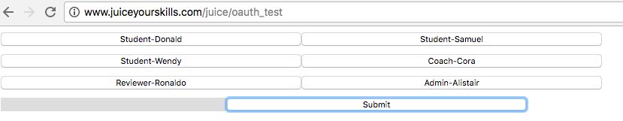

1. Enter your program id into the field called custom_program_key. The custom_program_key for “core JUICE” is AAGS. Core JUCE will also load if the custom_program_key is empty.

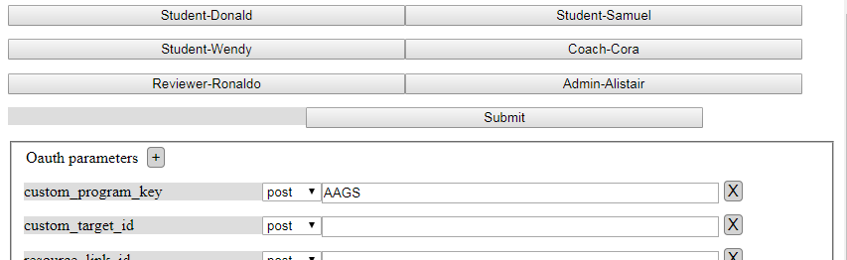

1. Update other form values as you desire and Click Submit. This will launch the JUICE dashboard in a new tab. If you don’t see it, look for it along the tab row in your browser. It should say ‘JUICE-Refresh your skills.’
2. To access a specific module page, enter this into the custom_target_id field:

module/[moduleid]

module/QS1.basic_math

Note: This is case sensitive, and will not work if you have space after the module id.   
  
You can find module ids by inspecting the URL field after you have loaded the module page from JUICE Home:



1. To access a mini-lesson page, enter this into the custom_target_id field:

modulette/[moduletteid].

modulette/QS1.1.

Notice the period after the modulette id! This is required!!!

Note: This is case sensitive, and will not work if you have space after the modulette id.

You can find modulette ids by inspecting the URL field after you have loaded the modulette page from JUICE home:  
 

1. To access the site as an Admin, Coach (instructor), or Reviewer, click one of the other buttons at the top of the page.
2. To view activity for a specific student, access the site as Cora Coach, and put the student’s user id into the custom_studentId field

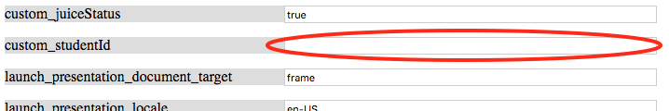

# LTI Launches

JUICE supports LTI v1.0 launches. The launch endpoint is as follows:

[/juice/process_oauth](https://www.juiceyourskills.com/juice/process_oauth)

The field values on the test page reflect the lti parameters.

The custom parameters custom_program_key and custom_target_id are required. Custom parameters can be sent as part of the POST, or as part of the URL sent to the endpoint as in this example:

<https://dev.juiceyourskills.com/juice/process_oauth?custom_program_key=AAGS&custom_target_id=dashboard>

The parameters are as follows:

| **parameter name** | **How JUICE uses this** | **Where stored** |
| --- | --- | --- |
| context_id | Treated as a course id.  Available as a filter on the JUICE activity report and other data tools. | User record, user activity data |
| context_label | Not currently used | User record |
| context_title | Not currently used | User record |
| launch_presentation_document_target | Not currently used |  |
| launch_presentation_locale | Not currently used |  |
| lis_person_contact_email_primary | Not currently used | User record |
|  |  |  |
| lis_person_name_family | Displayed in Try it item analysis reports | User record |
| lis_person_name_full | Displayed in Try it item analysis reports | User record |
| lis_person_name_given | Displayed in Try it item analysis reports | User record |
| lis_person_sourcedid | Not currently used | User record |
| lti_message_type | launch type |  |
| lti_version | lti version |  |
| oauth_callback | ignored |  |
| oauth_consumer_key | Authentication based on a shared secret that we generate and tell the tool consumer. |  |
| oauth_nonce |
| oauth_signature |
| oauth_signature_method |
| oauth_timestamp |
| oauth_version |
| resource_link_id | Can be used to tell JUICE what page to load.  If a custom_target_id is present, this is ignored.  If blank or not present, and no custom_target_id is provided, then the JUICE dashboard loads |  |
| roles | Coach role sees a special view of JUICE dashboard when "custom_studentid" is also present.  Admin role has access to reporting tools and other site admin capabilities. | User record, user activity data |
| tool_consumer_instance_guid | ID that identifies the tool consumer. | User record |
| user_id | Id that uniquely identifies the user. Stored with the user recored and activity data | User record |
|  |  |  |
| **Custom parameters** |  |  |
| custom_program_key  REQUIRED | Identifies the program that the user should be accessing.  If not included or not recognized, JUICE will load the core JUICE program. | User record |
| custom_studentid | If passed on a Coach or Educator launch, with custom_target_id=dashboard, will show student activity for the specified student.  Note: Equivalent roles can be defined in a JUICE config file. |  |
| custom_target_id  REQUIRED | Tells JUICE what page to load.  This overrides values in the resource_link_id. If this value is not present, and the resource_link_id is not a recognized target, JUICE will not load.  See below for possible values. |  |
| custom_source | Identifies where the student launched from. Included in student activity reports | User record, user activity data |

## custom_target_id values

Important! All custom_target_id values are case sensitive.

When passed into JUICE, they are appended onto the [yourdomain]/juice/ URL to form a complete path to the page you want to access.

| **To access** | **Use this value** |
| --- | --- |
| JUICE Home | dashboard |
| Specific module | module/[module id] |
| Specific mini-lesson | modulette/[modulette id]  The modulette id must have a trailing period! |
| Specific mini-lesson without showing breadcrumbs | modulette/[modulette id]/#slim |

You can find the module and modulette ids by accessing the desired content from the JUICE Home page and inspecting the URL:





# Social media log-in site

JUICE supports a standalone site that users can access using a Facebook, Google, Twitter, or Yahoo! log-in. The social media authentication is managed by the Janrain social login tool:

<https://www.janrain.com/products/manage-customer-identities/social-login>

The JUICE site is configured by default to require users to provide a social login access code defined by you and acknowledge JUICE terms of use after they have logged in via Janrain. You can also configure it to skip this step and log directly into JUICE.

To use the social media login site, you must do the following:

* + - 1. Define the social log-in site URL in the JUICE config file.
      2. Register with Janrain and configure the tool appropriately for the site.
      3. Set the configuration to log in directly if you desire. If you are requiring users to have a social access code and acknowledge the terms of use, download the Terms of Use document from docs/social_login_terms_and_conditions.html and update it as appropriate. Note: This document is also accessed from the current JUICE Welcome page and default JUICE help.
      4. Define social login access codes by editing the file /configs/social_login_access_codes.json
      5. After the updated social login access codes file is updated and uploaded, log in to the site as an admin, and access /juice/reload

## Editing /configs/social_login_access_codes.json

The social login access code json file looks like this. The first value in the json entry is the access code. In this case it is “sample social access code”:

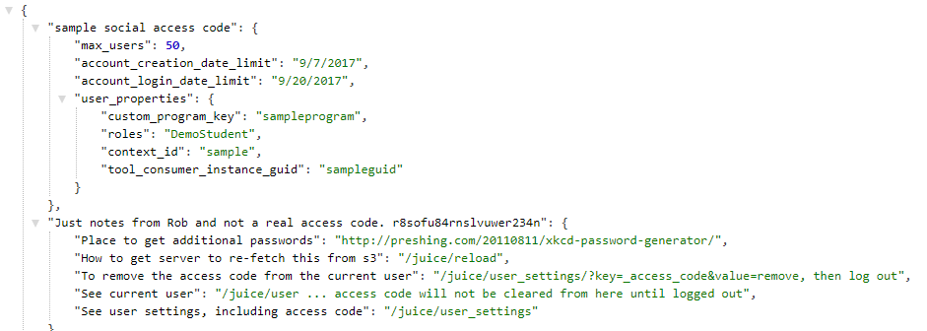

The other values are as follows:

| **Json parameter** | **What it’s for** |
| --- | --- |
| max_users | The social login access code used by a user is stored with that user’s record in the database.  “max_users” is the number of users that can have this code at one time. |
| account_creation_date_limit | This is the latest date that this code can be used to create accounts.  This value may be omitted entirely. |
| account_login_date_limit | This is the latest date that anyone with this code can log in. After this date has passed, anyone with this code will be prompted to enter a new code.  This value may be omitted entirely. |
| user_properties | Any user property associated with a specific social log in access code is stored with user and activity records.  Any value in the /juice/users record can be set by adding it to the social login access code definition.  User properties are optional, but as a best practice, you should always define the custom_program_key, roles, and context_id. |
| user_properties > custom_program_key | This tells JUICE what flavor of the site to load. If the value is not recognized, JUICE will load the core JUICE program. |
| user_properties > roles | This tells JUICE the role the student should have in the site. A role of Admin has special capabilities and access to reports. |
| user_properties > context_id | This is used as a filter in reports and is usually used to provide the context for the student—for example, a course id, or other type of cohort id. |
| user_properties>tool_consumer_instance_guid | This is appended to the user id. It is used as a filter in reports and used to keep users in separate pools in the database for the purposes of reporting. |
| user_properties > other….. | You can set values for any of the other fields in the user record in the database by adding them here. |

Remember to reload the social login access code json file by logging in as an admin, and accessing access /juice/reload.